**Lab 1: OSI Model**

**Objective:**

The objective of this experiment is to study and understand the **OSI (Open Systems Interconnection) reference model**, its **seven layers**, and the role each layer plays in the process of data communication

**Theory:**

The **Open Systems Interconnection (OSI) model**, developed by the International Standards Organization (ISO), is a conceptual framework that standardizes how data is transmitted and received across a network. It breaks the communication process into **seven distinct layers**, each handling specific functions and interacting with the layer above and below it.

**The Seven Layer:**

1. **Physical Layer**: Deals with the physical medium of communication such as cables, switches, voltages, and signal transmission. It ensures raw bits are transmitted from one device to another.
2. **Data Link Layer**: Responsible for node-to-node delivery, framing, error detection, and MAC addressing. It ensures data packets are transferred reliably over the physical link.
3. **Network Layer**: Manages logical addressing and determines the best path for data to travel using routing protocols. Internet Protocol (IP) is a prime example.
4. **Transport Layer**: Provides reliable or unreliable delivery of data, error recovery, segmentation, and flow control. Protocols like TCP and UDP function here.
5. **Session Layer**: Establishes, manages, and terminates communication sessions between applications. It keeps track of dialogs and synchronization.
6. **Presentation Layer**: Translates data into a format understandable by the application. It also handles encryption, decryption, and compression to ensure secure and efficient communication.
7. **Application Layer**: Closest to the user, it provides services such as email, web browsing, file transfer, and remote access.

**Conclusion**:

The OSI model simplifies understanding of network communication by dividing it into seven layers with specific roles. It remains an essential reference for learning, designing, and troubleshooting networks, even though modern networks often follow the TCP/IP model.

**Lab 2: Cable and Connectivity**

**Objective:**

The objective of this experiment is to study different types of **Ethernet networking cables**, specifically **straight-through** and **crossover** cables.

**Theory:**

Networking cables act as the physical medium through which data is transmitted between devices in a computer network. Ethernet cables, particularly straight-through and crossover, are the most commonly used in Local Area Networks (LANs). These cables are built using twisted pair wiring with RJ45 connectors at both ends. The wiring standard is defined by TIA/EIA568A and 568B. The way the wires are arranged at both ends determines the cable type and, therefore, its function.

* **Straight-Through Cable**:
  + Both ends of the cable follow the same wiring standard (either T568A–T568A or T568B–T568B).
  + This cable is mainly used to connect different types of devices, for example:
    - Computer → Switch
    - Computer → Router
    - Switch → Router
  + It is the most widely used type of Ethernet cable in modern networking.
* **Crossover Cable**:
  + One end follows the T568A standard and the other end follows T568B, which swaps the transmit (Tx) and receive (Rx) pairs.
  + This type of cable is used to connect similar devices, such as:
    - PC → PC
    - Switch → Switch
    - Router → Router
  + While Auto-MDI/MDIX technology in modern switches and NICs can automatically detect and adjust connections, understanding crossover cabling remains essential for theoretical knowledge and troubleshooting in cases where auto-detection is unavailable.

**Conclusion:**

Straight-through cables are used to connect **different devices**, while crossover cables connect **similar devices.** Understanding these cabling methods is essential for building and troubleshooting reliable network connections.

**Lab 3: Hub and Switch**

**Objective:**

The objective of this experiment is to study the working principles of Hub and Switch in networking, compare their functions, and understand how they affect data transmission within a Local Area Network (LAN).

**Theory:**

In computer networking, hubs and switches are devices used to connect multiple computers or devices in a LAN. Both operate at different layers of the OSI model and handle data transmission differently.

* **Hub:**
  + Operates at the Physical Layer (Layer 1) of the OSI model.
  + A hub simply broadcasts incoming signals to all connected devices, regardless of the destination.
  + Because of this, only one device can effectively communicate at a time, leading to collisions and reduced network efficiency.
  + Hubs are inexpensive and simple but are largely obsolete in modern networks due to their limitations.
* **Switch:**
  + Operates at the Data Link Layer (Layer 2) of the OSI model.
  + A switch uses MAC addresses to identify devices and forward data only to the intended destination port.
  + This reduces unnecessary traffic, minimizes collisions, and improves network speed and efficiency.
  + Modern switches may also operate at higher layers (Layer 3 switches), providing routing and additional management features.

**Comparison**:

1. **Hub**: Simple, broadcasts to all, prone to collisions, less secure.
2. **Switch**: Intelligent, forwards only to the target device, efficient, secure, and widely used in modern LANs.

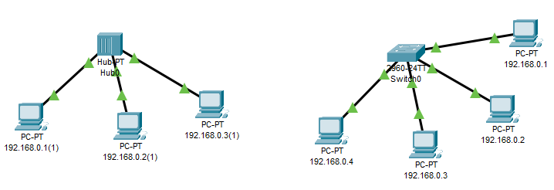**Input/Output:**

**Conclusion:**

A hub is a basic device that broadcasts data to all connected devices, while a switch intelligently forwards data to the correct destination. Switches are faster, more secure, and more efficient, making them the standard choice in modern networking over hubs.

**Lab 4: HTTP, DHCP, DNS server**

**Objective:**

The objective of this experiment is to study the roles of HTTP, DHCP**,** and DNSservers in computer networks, understand how they function within the OSI/TCP-IP model, and identify their importance in enabling communication and services across the internet and local networks.

**Theory:**

Servers in networking provide essential services that allow devices to communicate and access resources efficiently. Among them, HTTP, DHCP, and DNS servers play crucial roles:

* **HTTP (Hypertext Transfer Protocol) Server**:
  + Operates at the Application Layer of the OSI model.
  + It delivers web content (HTML pages, images, files) to clients (browsers) over the internet or intranet.
  + Works on a request-response model where the client sends an HTTP request, and the server responds with the requested data.
  + Commonly uses port 80 (HTTP) or port 443 (HTTPS for secure communication).
* **DHCP (Dynamic Host Configuration Protocol) Server**:
  + Operates at the Application Layer, but provides services closely tied to the Network Layer.
  + Automatically assigns IP addresses, subnet masks, default gateways, and DNS information to client devices.
  + This eliminates the need for manual configuration, reduces errors, and allows devices to join a network seamlessly.
  + Uses ports 67 (server) and 68 (client) for communication.
* **DNS (Domain Name System) Server**:
  + Also functions at the Application Layer.
  + Translates human-readable domain names (e.g., www.google.com) into IP addresses (e.g., 192.168.1.1) that computers use to identify each other on the network.
  + Acts like a “phonebook” of the internet, enabling users to access websites without memorizing numerical IP addresses.
  + Typically operates on port 53 (UDP/TCP).

Together, these servers enable smooth networking: HTTP provides content, DHCP ensures devices have valid network configurations, and DNS allows user-friendly access to resources.

Input/Output:

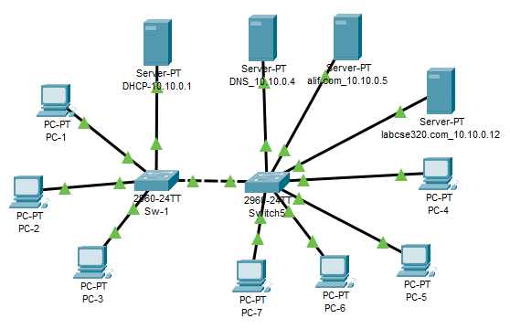

**Conclusion:**

HTTP, DHCP, and DNS servers are fundamental components of modern networking. HTTP delivers web content, DHCP automates IP configuration, and DNS resolves domain names to IP addresses. Combined, they simplify communication, improve efficiency, and provide the backbone for everyday internet and network services.

**Lab 5: SMTP, POP3, FTP**

**Objective:**

The objective of this experiment is to study the functions of **SMTP, POP3, and FTP protocols**, understand their roles in communication and data transfer, and learn how they operate within the OSI/TCP-IP model.

**Theory:**

Networking protocols define rules for communication between devices. SMTP, POP3, and FTP are key application-layer protocols used for email and file transfer services:

* **SMTP (Simple Mail Transfer Protocol)**
  + Operates at the Application Layer of the OSI model.
  + Used to send and relay emails between mail servers and from clients to servers.
  + Works on a push model, meaning messages are sent to the server or another mail server for delivery.
  + Commonly uses port 25 (default), port 465 (SMTPS), or port 587 (submission).
* **POP3 (Post Office Protocol, version 3)**
  + Also operates at the Application Layer.
  + Used by email clients to retrieve emails from a mail server.
  + Downloads messages from the server to the client’s device and usually deletes them from the server afterward (unlike IMAP, which keeps a copy).
  + Uses port 110 (default) and port 995 (POP3S with SSL/TLS).
* **FTP (File Transfer Protocol)**
  + Operates at the Application Layer.
  + Used to transfer files between a client and a server over a TCP/IP network.
  + Supports user authentication (username/password) and different modes of transfer (ASCII, Binary).
  + Uses port 21 for control commands and port 20 for data transfer.

Input/Output:

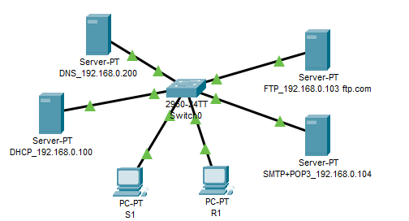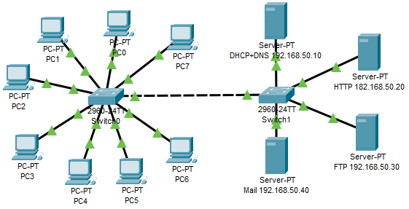

**Conclusion:**

SMTP, POP3, and FTP are fundamental application-layer protocols. SMTP enables email sending, POP3 allows users to retrieve emails, and FTP facilitates file transfer. Together, they form the backbone of email and file-sharing services in computer networks.

**Lab 6: Router**

**Objective:**

The objective of this experiment is to study the role of a **Router** in networking, understand how it operates within the OSI model, and learn its importance in connecting multiple networks and directing data packets efficiently.

**Theory:**

A Router is a networking device that operates mainly at the Network Layer (Layer 3) of the OSI model. Its primary function is to connect different networks and forward data packets between them based on their IP addresses. Unlike switches or hubs that operate within a single LAN, routers allow communication between multiple LANs and between a LAN and the internet.

**Key Functions of a Router:**

* **Packet Forwarding**: Examines the destination IP address of incoming packets and forwards them to the correct next hop or network.
* **Routing Table**: Maintains a table containing network paths to determine the most efficient route for data transmission.
* **Routing Protocols**: Uses protocols such as RIP, OSPF, or BGP to dynamically learn and update routes.
* **Network Segmentation**: Divides large networks into smaller subnets, improving performance and reducing congestion.
* **Security and Filtering**: Many modern routers include firewall functions, NAT (Network Address Translation), and access control for secure communication.

Routers are essential for **internet access**, as they connect local networks to external networks (e.g., ISP to home/office LAN).

**Input/Output:**

**Conclusion:**

A router is a Layer 3 device that connects different networks and directs data packets using IP addresses. It ensures efficient communication, provides network segmentation, and enables internet connectivity, making it a critical component of modern networking.